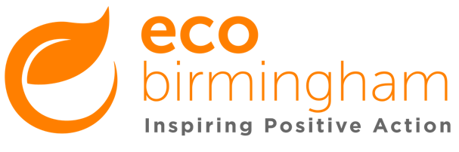

Job Description: Fundraising and Projects Assistant

Salary: £20,378 pro-rata (£10.45 per hour)

Conditions: 21 days holiday + bank holidays (both pro-rata per year)

Hours of Work: 30 hours per week (0.8 fte) – to include Tuesday-Thursdays.

Reports to: Project Coordinator Supervises: Volunteers

Place of work: Northfield Ecocentre, 53 Church Rd, Northfield.

Main purpose of the job:
The aim of the role is to help manage and fundraise for our community projects and to provide project support for a range of our sustainability projects. This will involve research, monitoring and engagement both online and offline on a range of sustainability related topics.

- Fundraising and income generation activities: assist with our fundraising applications and activities primarily through small trusts and foundations and digital fundraising campaigns.
- Increase skills base in our community: Assist in managing community and city-wide projects on different aspects of sustainable living and to engage and develop a network of community organisations to share ideas & skills.
- Assist with the running of events: Develop marketing and resources as needed.
- Assist the project co-ordinators in monitoring involvement with the projects: Record monitoring data and feedback for those attending events, groups and workshops.

Any special conditions:
This post may occasionally require flexibility to work unsociable hours at weekends and evenings and will be subject to a DBS check.
We do not accept CVs. Please return your completed application form by 5pm Monday 13 September 2021 to info@ecobirmingham.com (preferred) or by post to 53 Church Rd, Northfield, Birmingham. B31 2LB
Interviews will be held on 22 or 23 September 2021.
Person Specification

Qualifications
Relevant experience or related qualification | Desirable
Skills and Abilities
Good organisational and planning skills | Essential
Excellent interpersonal and communication skills (verbal and written) | Essential
To prioritise workloads, meet deadlines and work independently with attention to detail | Essential
To work as a member of a team, delegate and motivate | Essential
To use a range of IT products such as Microsoft Office, CRM system, Wordpress, social media channels | Essential
Research tasks | Essential
To give and receive constructive feedback | Essential
To assist writing, editing and producing marketing copy for events and blogs and materials on environmental education and sustainability topics | Desirable
Experience and Knowledge
Fundraising and income generation | Essential
Engaging communities in local projects | Essential
Working with people of all ages, backgrounds and abilities | Desirable
Working with, supporting and managing volunteers | Desirable
Sustainable living | Desirable
Other requirements
Ability to demonstrate an understanding of and commitment to our values and sustainable living | Essential
Commitment to promoting equal opportunities and diversity in the workplace | Essential
Flexibility with time and working hours | Essential

