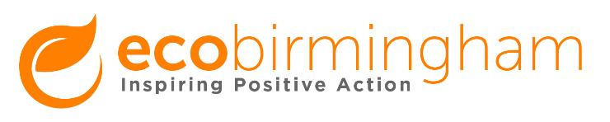

Freelancer Advert

Could you join our team at ecobirmingham as a freelancer?

ecobirmingham is an award-winning sustainability charity, supporting greener, fairer and healthier communities in Birmingham. We connect individuals to the skills, information and resources that can help them make steps on their sustainable journey. This includes access to cycling, walking, education, community gardening, healthy eating, carbon reduction, energy and waste advice, and community development.

Our current team need a number of new freelancers to support our work. These roles are paid an agreed hourly or daily rate to help our existing services deliver more activity and identify new opportunities.

Freelance roles and opportunities include:
- Active Travel - Cycle instruction, led rides, and maintenance.
- Food - Community gardening design and planning.
- Sustainability - Advice, audits and training.

The Sustainability Freelancer roles include support to develop our advice, audit and training services such as sustainability reviews or ‘One Planet Living’ action planning for individuals, households and small organisations. We are looking for the following expertise:

- Energy and carbon advice and audits
- Waste and recycling advice and audits
- Environmentally friendly purchasing, consumer advice, including financial products
- Employment, education, training for access to ‘Green Jobs’ focused on post 16 education sector and mid-career retraining
- Weather resilience –coping with flooding, heat, and other extreme weather, and conserving water
- Healthy and planet friendly cooking and eating
- Physical and mental health improvement linked to the design of environmental community projects
- Advocacy and campaigns, and how to work with the local democratic and civic process to achieve change

To find out more:
Contact esther@ecobirmingham.com for enquiries about the active travel role, jackie@ecobirmingham.com for the food role and simon@ecobirmingham.com for the sustainability role.

To apply:
Applications will be reviewed on a rolling basis. To apply, send a covering letter of no more than two sides to anne@ecobirmingham.com, setting out why you are interested in the role, and how you meet the requirements of the position.

